- Write program demonstrates how to use regular expressions in Python to match and search for patterns in text.
Code:
import re
pattern1 = r"My"
match = re.match(pattern1, text)
if match:
print("Match found at the beginning:", match.group())
else:
print("No match found at the beginning.")
search = re.search(pattern2, text)
if search:
print("Phone number found:", search.group())
else:
print("Phone number not found.")
# 3. Search for an email address
email_pattern = r"\b[\w\.-]+@[\w\.-]+\.\w+\b"
email = re.search(email_pattern, text)
if email:
print("Email found:", email.group())
else:
print("Email not found.")
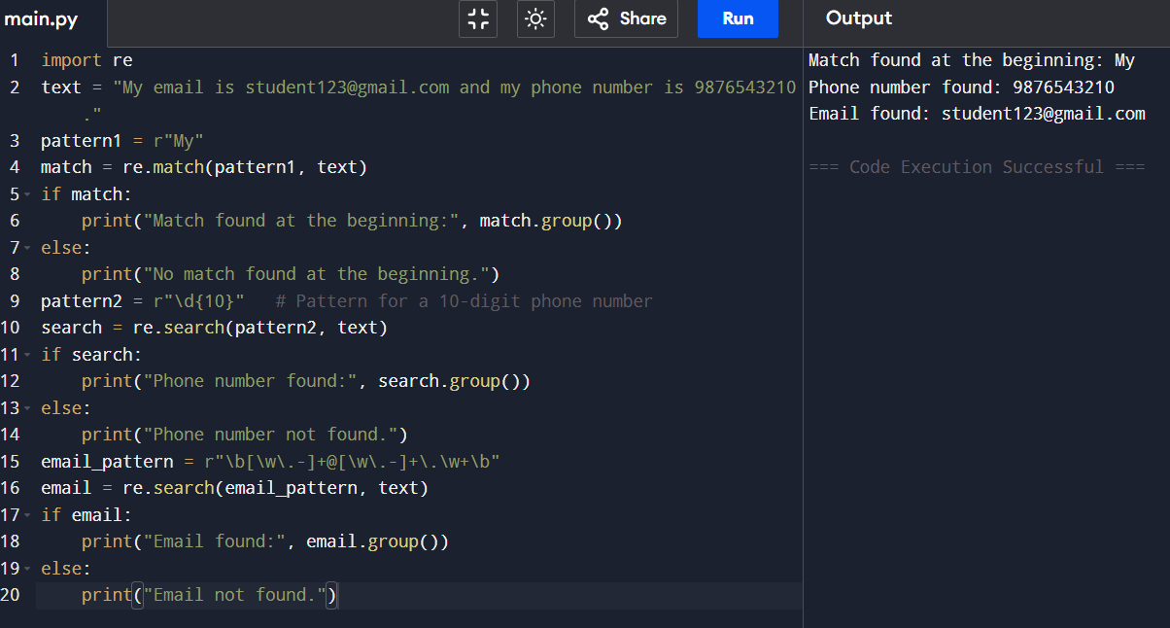
Output:
- Implement a basic finite state automaton that recognizes a specific language or pattern. In this example, we'll create a simple automaton to match strings ending with 'ab' using python.
Code:
def fsa_ends_with_ab(string):
state = 0
for ch in string:
if state == 0:
if ch == 'a':
state = 1
else:
state = 0
elif state == 1:
if ch == 'b':
state = 2
elif ch == 'a':
state = 1
else:
state = 0
elif state == 2:
if ch == 'a':
state = 1
else:
state = 0
if state == 2:
print("Accepted")
else:
print("Rejected")
# Example
s = input("Enter a string: ")
fsa_ends_with_ab(s)
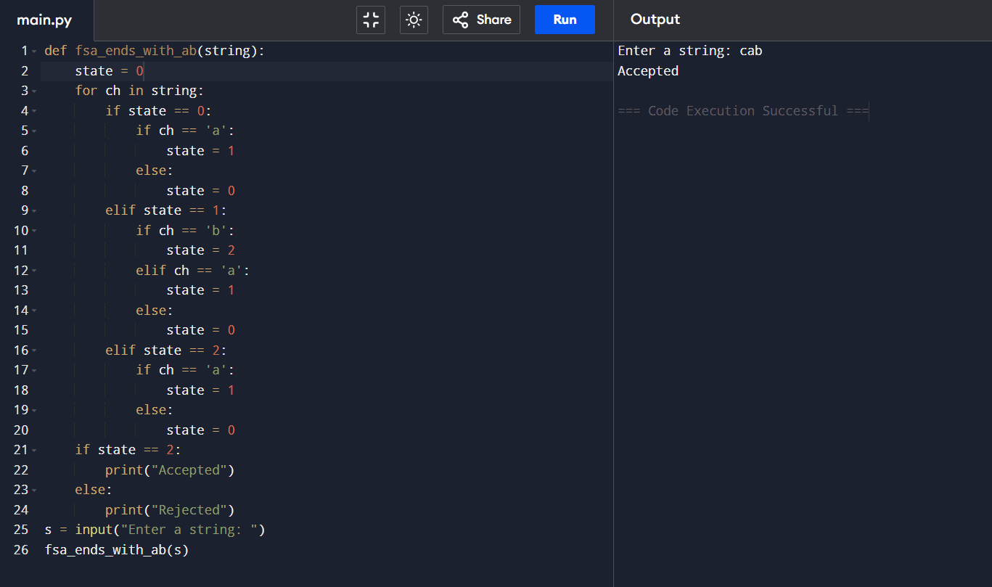
Output:
- Write program demonstrates how to perform morphological analysis using the NLTK library in Python.
Code:
words = ["running", "playing", "studies", "cars"]
print("Morphological Analysis")
for word in words:
if word.endswith("ing"):
root = word[:-3]
elif word.endswith("ies"):
root = word[:-3] + "y"
elif word.endswith("s"):
root = word[:-1]
else:
root = word
print("Word :", word)
print("Root :", root)
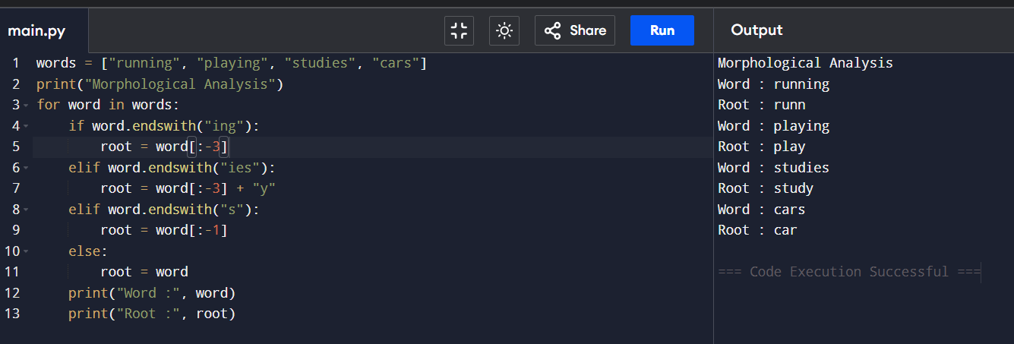
Output:

- Implement a finite-state machine for morphological parsing. In this example, we'll create a simple machine to generate plural forms of English nouns using python.
Code:
# Finite State Machine for Morphological Parsing
# Generates plural forms of English nouns
def generate_plural(noun):
# State q0 (Start State)
if noun.endswith(("s", "x", "z", "ch", "sh")):
# Transition to q1
plural = noun + "es"
elif noun.endswith("y") and len(noun) > 1 and noun[-2].lower() not in "aeiou":
# Transition to q2
plural = noun[:-1] + "ies"
else:
# Transition to q3
plural = noun + "s"
return plural
# Test words
words = ["cat", "dog", "bus", "box", "church",
"dish", "baby", "city", "toy", "book"]
print("Singular\tPlural")
print("------------------------")
for word in words:
print(f"{word:10}\t{generate_plural(word)}")
Output:
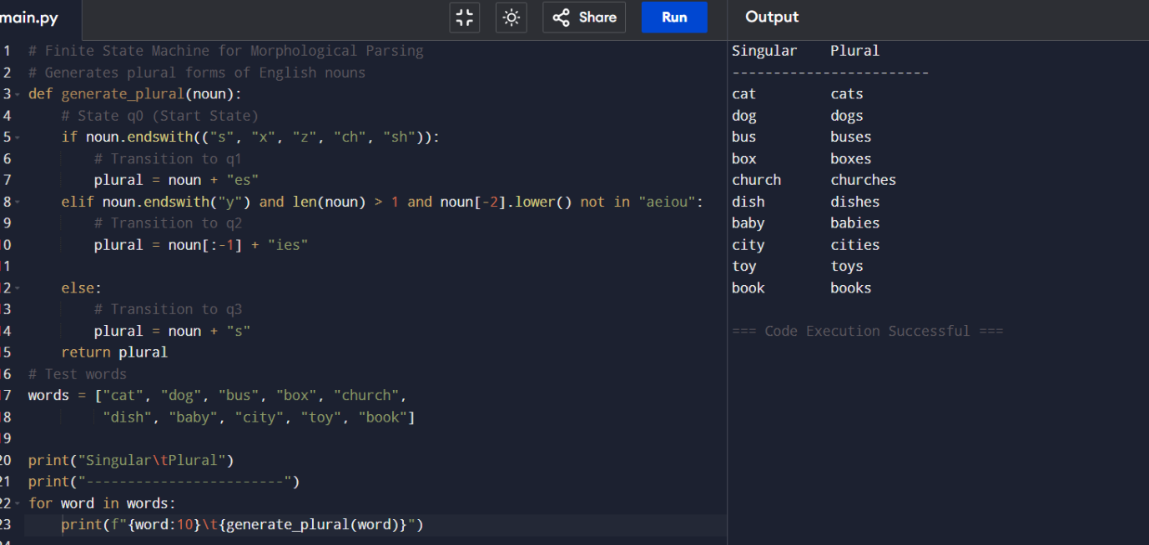

- Use the Porter Stemmer algorithm to perform word stemming on a list of words using python libraries.
Code:
words = ["running", "playing", "studies", "studying",
"connected", "connection", "happiness",
"flying", "wolves", "cars"]

stems = ["run", "play", "studi", "studi",
"connect", "connect", "happi",
"fli", "wolv", "car"]

print("Original Word\tStemmed Word")
print("-" * 35)

for w, s in zip(words, stems):
print(f"{w:<15}{s}")

Output:
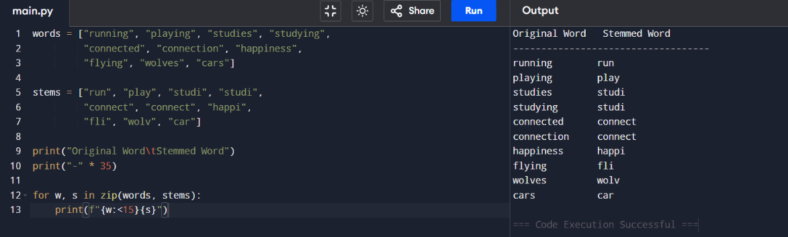
- Implement a basic N-gram model for text generation. For example, generate text using a bigram model using python.
import random
# Sample text
text = "I love natural language processing and I love python programming"
# Split text into words
words = text.split()
# Create bigrams
bigrams = {}
for i in range(len(words) - 1):
word = words[i]
next_word = words[i + 1]
if word not in bigrams:
bigrams[word] = []
bigrams[word].append(next_word)
# Generate text
current_word = "I" # Starting word
generated_text = [current_word]
for i in range(10):
if current_word in bigrams:
next_word = random.choice(bigrams[current_word])
generated_text.append(next_word)
current_word = next_word
else:
break
print("Generated Text:")
print(" ".join(generated_text))
Output:
